5. Mark Sheet Processing System
Aim: To create a cloud-based Mark Sheet Processing System using Zoho Creator to store student marks and calculate academic performance.
Procedure:
- Log in to Zoho Creator and create a new application.
- Create a form named Student Mark Sheet.
- Add fields such as Student Name, Register Number, Subject, Marks, Average, Percentage, Rank, and Overall Performance.
- Enter the student marks and calculate the average and percentage.
- Save and view the student records.
Implementation:
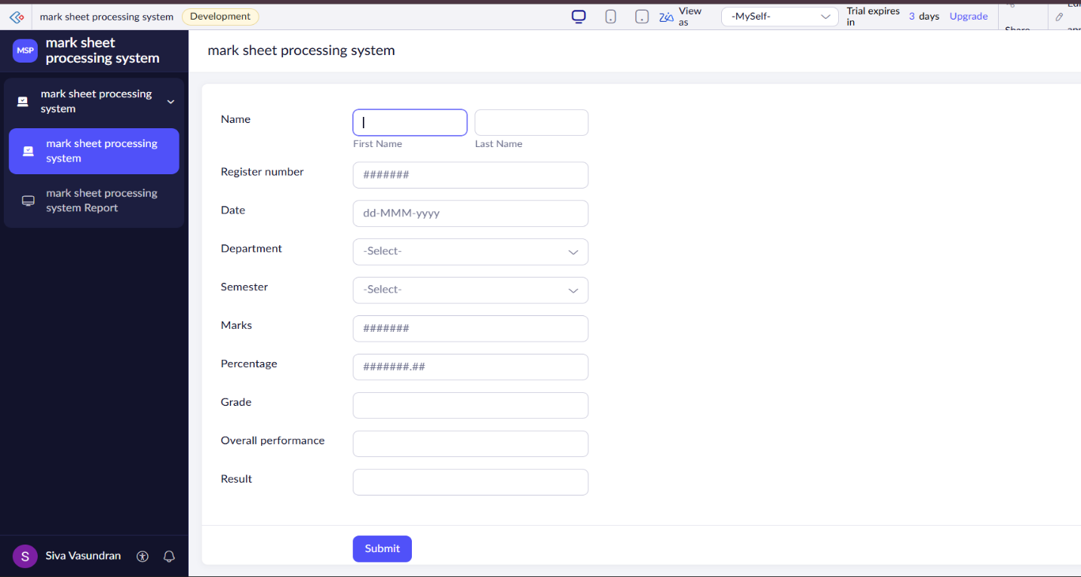
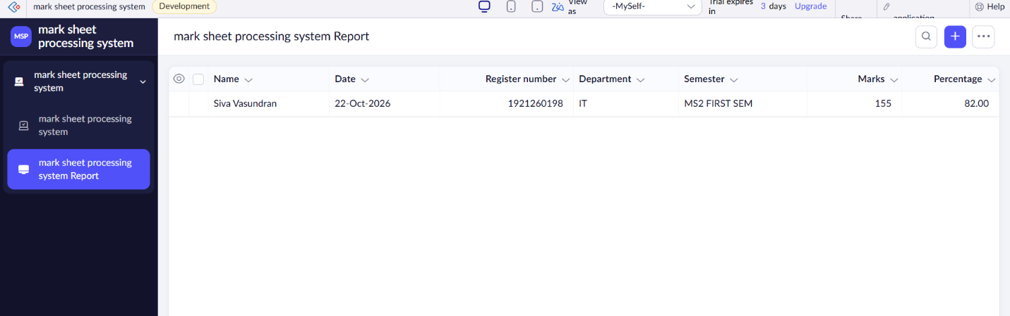

Result: Thus, a cloud-based Mark Sheet Processing System was created successfully to manage student marks and academic results.

